Using Mobile NMR Spectroscopy to Study Chemical Problems
in a Factory Environment

Matthew P. Augustine

Department of Chemistry, University of California, Davis, California 95616, United States
maugust@ucdavis.edu

Modern permanent magnet and radio frequency electronics technology now make NMR spectroscopy amenable to process control in real factory environments. In comparison to large, expensive, laboratory anchored superconducting magnet based spectrometers, it is the decreased size and durability of systems based on these technological advances that now allows NMR to provide real time feedback during industrial processes. The factory environment presents an interesting spectrometer building challenge as standard 5 mm diameter glass tubes containing pure compounds or simple mixtures are rarely encountered. Samples are typically well-defined, reproducible complex mixtures presented in metal pipes at ambient or elevated pressure or in large aseptic metal containers. Early work involving the NMR study of industry standard sealed “Coke” cans is extended here to study tomato spoilage in 1,000 liter, 1 ton aseptic containers with single sided magnets of varied construction and coil arrangement. The design and construction of the recently deployed NMR based tomato spoilage detector will be described. Other early NMR work involving the study of aqueous geochemistry at up to 3 GPa pressure is also extended here to study both food and biomass in a high pressure processing (0.5 GPa) situation for the first time.

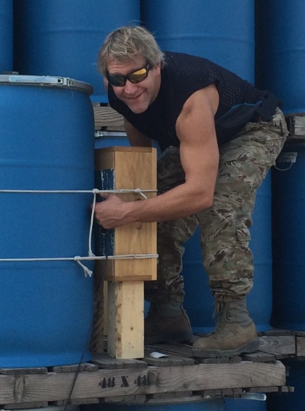
Biography:

Matt Augustine is a Professor and Vice – Chair of Chemistry at UC Davis. He received his BS in Chemistry from Penn State University, focused on the application of NMR to problems in Physical Chemistry as a graduate student with Kurt Zilm at Yale University, and refined his spectroscopic and theoretical skills as a National Science Foundation post-doctoral scholar in Alex Pines lab at UC Berkeley. Matt has spent his entire career at UC Davis, beginning as an Alfred P. Sloan and David and Lucile Packard fellow, serving the campus community as a member of the College of Letters and Science Executive Council, a Faculty Assistant to the Math and Physical Science Dean, and more recently a Vice – Chair of the Chemistry Department, and receiving the UC Davis Distinguished Teaching Award. His research is not conventional, has led to several patents and a wine analysis company. His primary interest is to make the outdoor environment his laboratory by developing field-deployable, rugged instruments to perform spectroscopic measurements and solve chemical problems at the point of care – a factory, a wine cellar, a mountain, etc.

